ERD Diagrams

Hotel SQL Server ERD
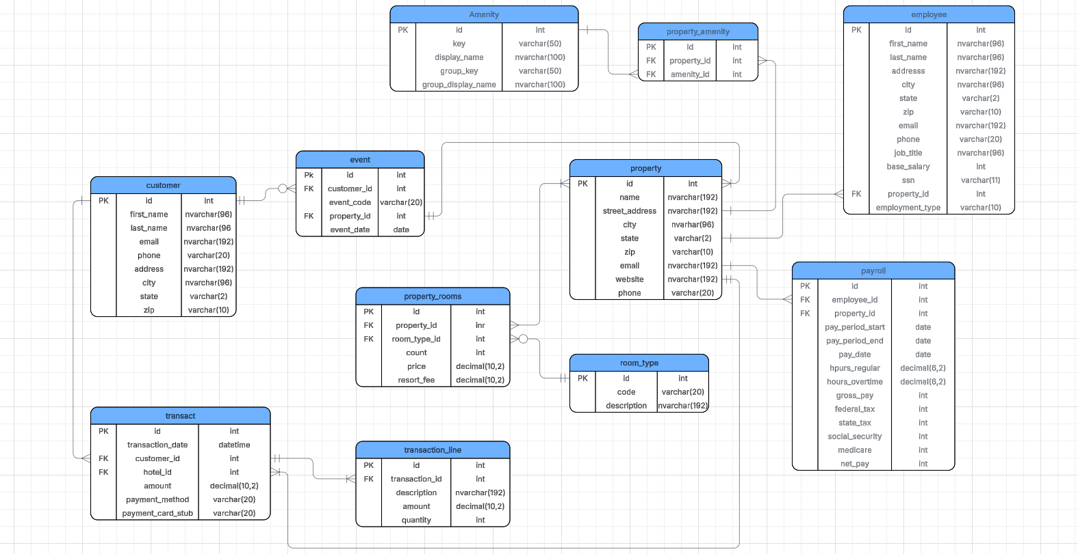

Gift Shop MongoDB Collections ERD
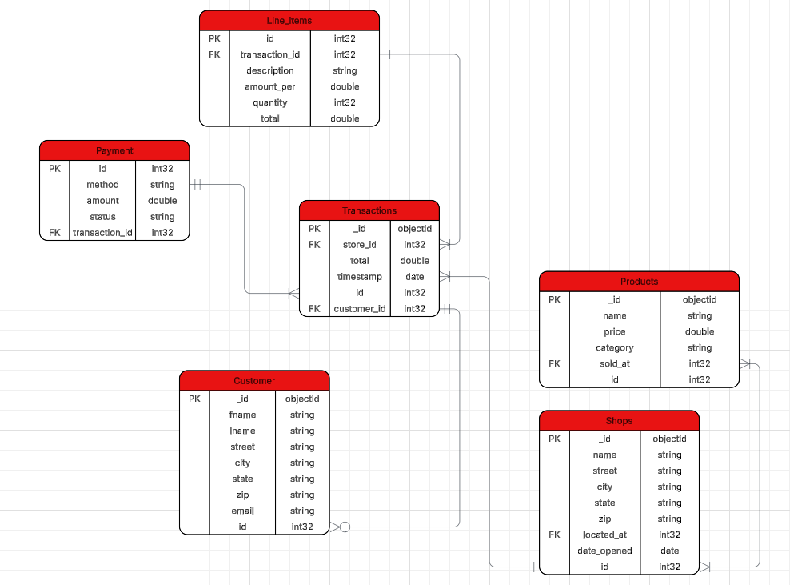

Fact Checkin Star Schema
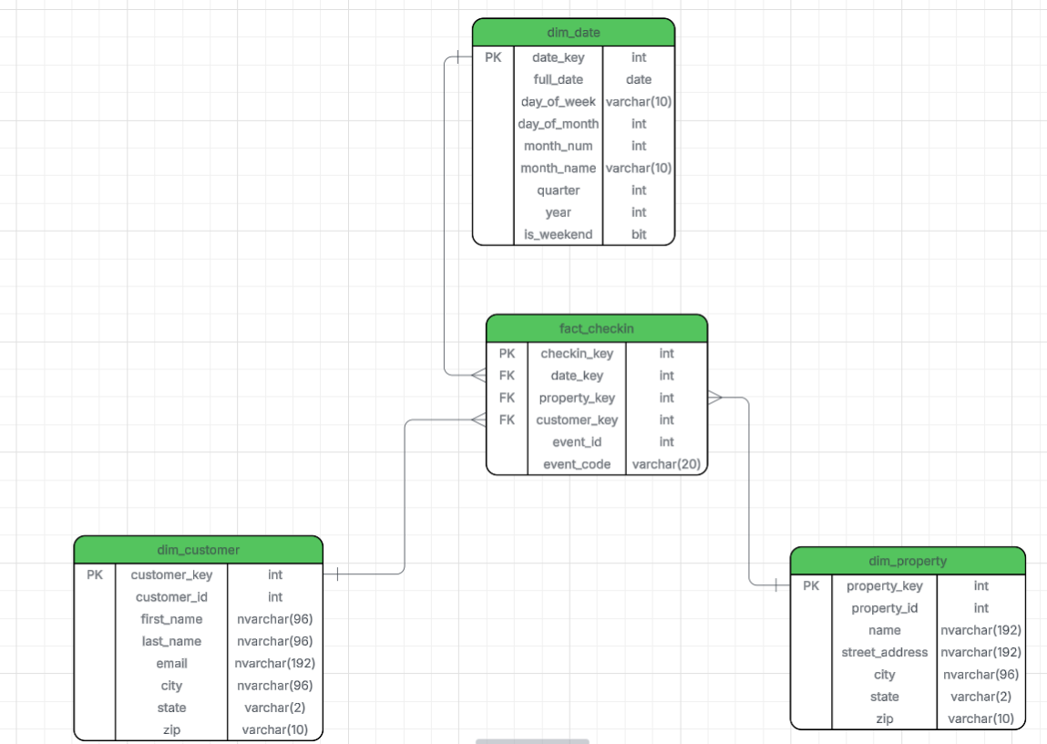

Fact Revenue Star Schema
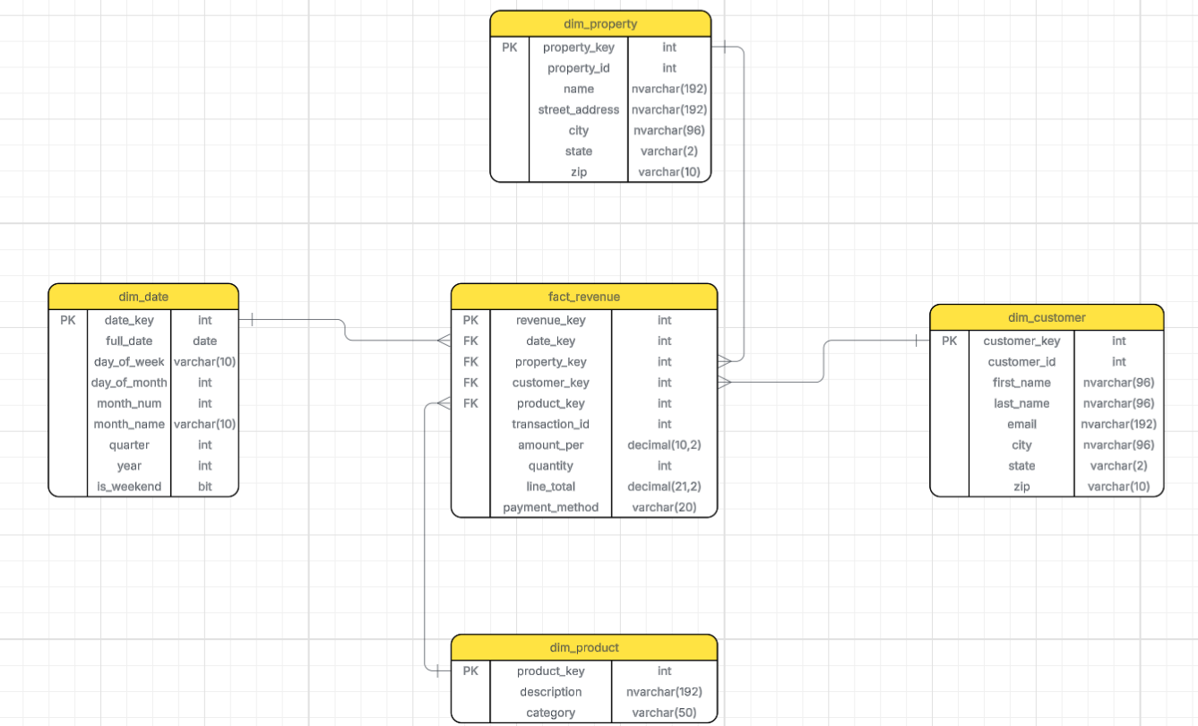

Fact Gift Shop Sales Star Schema
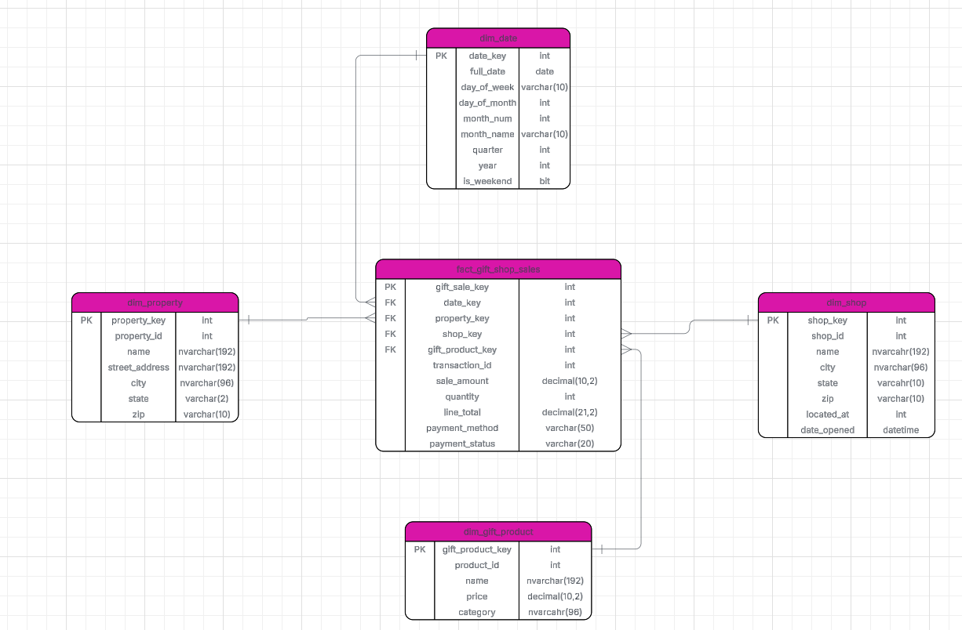

Fact Payroll Star Schema
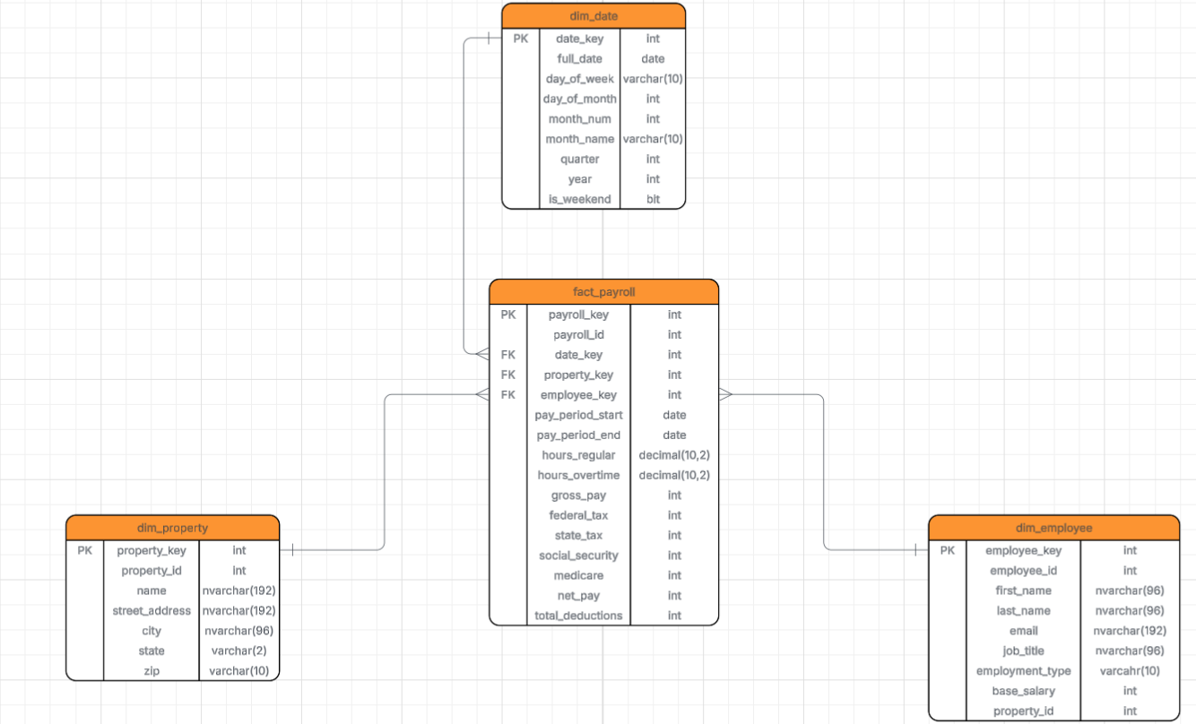

Fact Property Amenity Star Schema
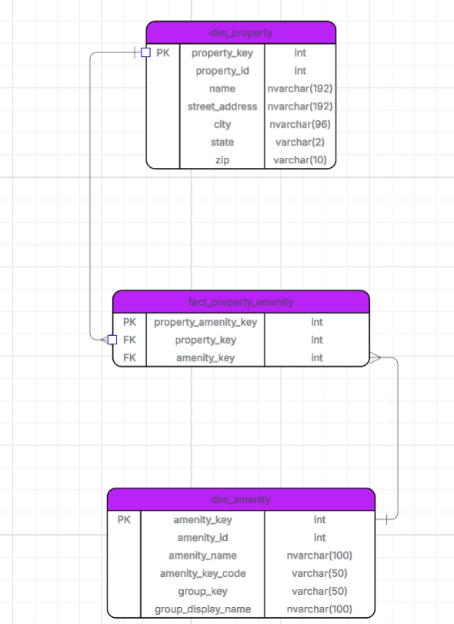
Hotel DGDB ERD
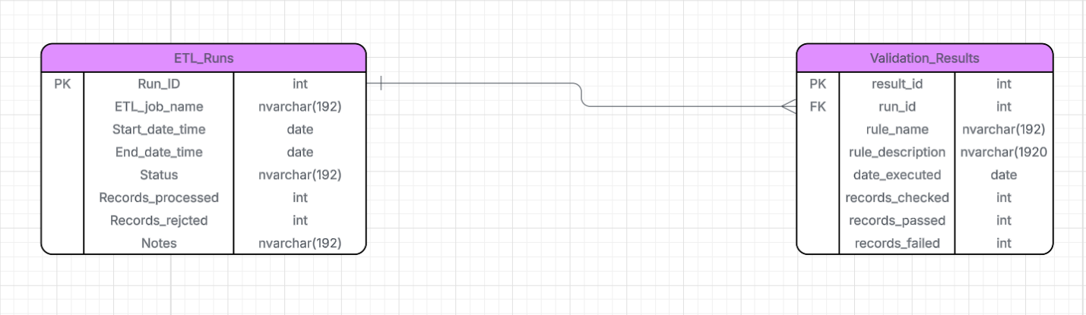

ETL Metadata ERD
